**Term work 1**

NAME: XXX DATE: 30/03/2023

USN: 2GI20CSXXX

Software Delay

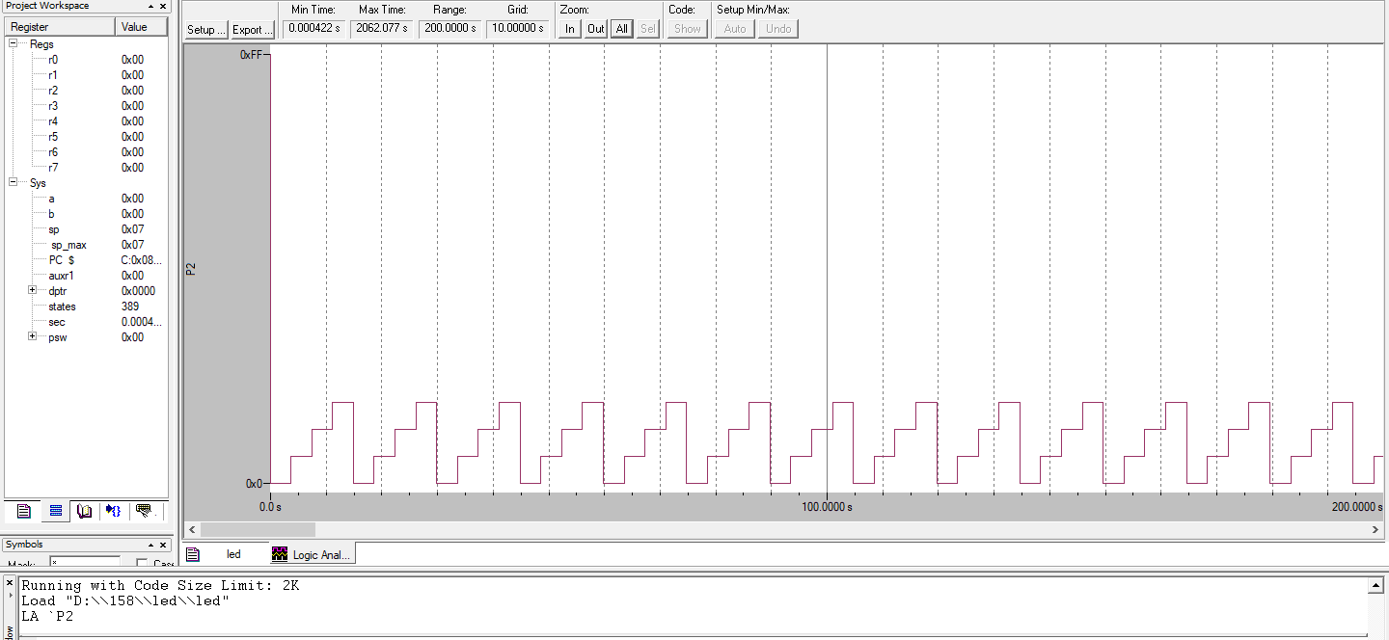

Hardware Delay

